## Magic- 55 Document

Magic- 55 Document 1

User Opt- In / Signup flow 2

Technology Decisions 2

Azure Resources estimated cost. 3

Deployment 3

Power Pages Pricing Apps 3

## User Opt- In / Signup flow

Our understanding of the client flow is as follows along with the opt in api flow

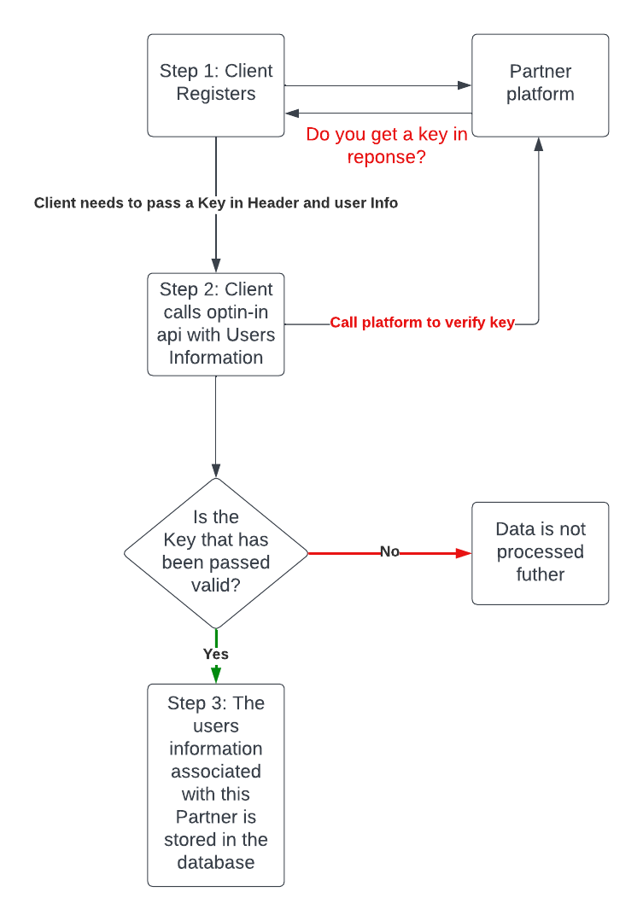

1. Do you get a key in response once the client registers on the partner platform?
2. Can we call the partner platform to verify the key?

## Technology Decisions

|  |  |  |
| --- | --- | --- |
| **Component** | **Beta** | **Comments** |
| User Authentication | Tokens | B2C user signup/signin flow |
| Device Authentication | Tokens | Above should cover it |
| UserOptIn API | Azure function app | The workflow for this is not very complicated we can go with Azure functions and keep it http trigger based |
| Secret store - Password, certificates | Azure key vault | Azure Key vault is very secured |
| Build and deploy | Github | We can switch to AzureDevOps later if needed. For now, github actions can be used.  Also, need to check if AzureDevOps is free with your license |
| Monitoring | App insights | With Azure functions we can use app insights for monitoring. But we need not switch on just yet. Let's keep it configured though |
| API Config | Json | Azure app service / azure functions both have app settings that can be configured |
| User Dashboard | Custom web page hosted in Azure | Can go with microsoft power apps. But if you show the design what you are expecting then we can even suggest a single page application that is hosted on Azure app service |
| DB – SQL | Standard license | Or you could go with Azure PostGreSQL, which is at a lower price if you use 1 year reserved instance |

## Azure Resources estimated cost.

1. Azure Function App
2. App Service Plan [ Only Premium and consumption plan is available in UK South]

Plan Type: - Premium

Hardware View: - 2Cores/7GB Ram / 250 GB Storage

Cost – 250 USD [ Single instance]

1. Azure App Service
2. App Service Plan [ All plans are available in UK South]

Plan Type: - Standard #recomended if application is of smaller size.

Hardware View: - 2Cores/3.5GB /50GB Storage

Cost – 185 USD [ Single Instance]

Plan Type: - Premium v2

Hardware View: - 2Cores/7GB Ram / 250 GB Storage

Cost – 365 USD [ Single Instance]

1. Azure SQL Database
2. Service Tier: - Standard S0
3. Redundancy: - LRS [ recommended to start with in Dev environment]
4. Performance Level: - 10 DTU, 250 GB storage per DB
5. Cost: - 18.40 USD estd. [ Varies according to no. of DTU]

Deployment

Initially can be done by Using GitHub Action later switch to Azure DevOps when application count increases.

## Power Pages Pricing Apps

In this case we may want authenticated users as we want role-based access to dashboard?

Subscription Based Plan: - Best for the business that want to predictable costs, with volume-based plans that scale.

Categories: -

NOTE: - licences to be purchase in the form of capacity pack

1. **Authenticated Users: -** [ Fixed no of users who authenticated each month]

**Cost**: - $200 per capacity pack/site/month

Volume Pricing

|  |  |  |  |
| --- | --- | --- | --- |
| Tiers | Minimum Requirement | Users /Capacity Pack | Price/ Capacity Pack |
| Tier 1 | 100 users | 1 pack | $200 |
| Tier 2 | 10,000 users | 100 pack | $75 |
| Tier 3 | 100,000 users | 1000 pack | $50 |

1. **Anonymous Users: -** [ who do not login just surf to the public exposed page]

**Cost**: - $75 per capacity pack/site/month

Volume Pricing

|  |  |  |  |
| --- | --- | --- | --- |
| Tiers | Minimum Requirement | Users /Capacity Pack | Price/ Capacity Pack |
| Tier 1 | 500 users | 1 pack | $75 |
| Tier 2 | 10,000 users | 20 pack | $37.50 |
| Tier 3 | 100,000 users | 200 pack | $25 |

Pay as you Go Plan: - Best for business seeking the option to pay only when a user accesses a website.

Categories: -

1. **Authenticated Users: -** [ Fixed no of users who authenticated each month]

**Cost**: - $4 per user/site/month

1. **Anonymous Users: -** [ who do not login just surf to the public exposed page]

**Cost**: - $0.30 per capacity user/site/month